**Call for Cleveland Institute of Art Student Jurors**

Sam Moran, Event Coordinator

[smoran@clevelandfoundry.org](mailto:bmonaco@clevelandfoundry.org)

440-331-4606

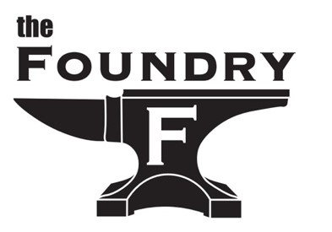

**$200 Stipend**

Power of Wind 3rd Annual Juried Student Art Exhibition for 6th-12th graders

**Apply Here**

Submit three pieces of your artwork with a brief narrative and a CIA staff referral for consideration.

**Application Deadline Jan. 30, 2025, 12:00 pm**

All applicants will be notified by Feb. 7, 2025.

**Why Be a Juror?**

Are you ready to make an impact, gain professional experience, and support the next generation of Cleveland’s young artists?

As a juror, you’ll play a pivotal role in recognizing the artistic talents of students from Cleveland area schools, many of which serve at-risk youth from low-income backgrounds. Your participation will help these young artists shine, showing them that their voices and talents matter as you experience the rewards of engaging with emerging artists and influencing their creative journeys.

**Building on Success**

In 2023, with the support of Jeffrey Allen, Art Director of Cleveland Metropolitan School District, Dennison Creative, and Cuyahoga Arts and Culture, the inaugural show featured 96 students from 9 Cleveland schools, drawing an audience of over 100 attendees. In 2024, CIA student jurors stepped in, elevating the event further. Despite a late outreach start, over 60 entries from 11 schools were submitted. Your involvement in 2025 can help us reach new heights, expanding the event’s reach and impact while showcasing the incredible talent our city’s youth has to offer.

**Three Jurors will be selected and receive a $200 stipend to complete the following tasks:**

* Create a PowerPoint presentation for juror use of the art entries electronically received
* Review approx.150 middle/high school students' electronic arts submissions.
* Select 60 pieces for the opening exhibit and juror’s in-person judging using the established criteria, scorecard, and processes noting improvements where applicable.
* Set up and print artist didactics, QR codes, and narratives.
* Hang art at The Foundry on an agreed-upon date of the jurors and Foundry staff.
* Select the winners for best of show, and 1st, 2nd, 3rd, and honorable mentions in two age categories
* Attend the exhibition on Thurs. April 24, 2025, at The Foundry at their waterfront Cleveland Flats location engaging in conversations with artists and families. Provide artist feedback using QR codes.

*Thank you for joining us in encouraging the creative talents of Cleveland’s young artists.*